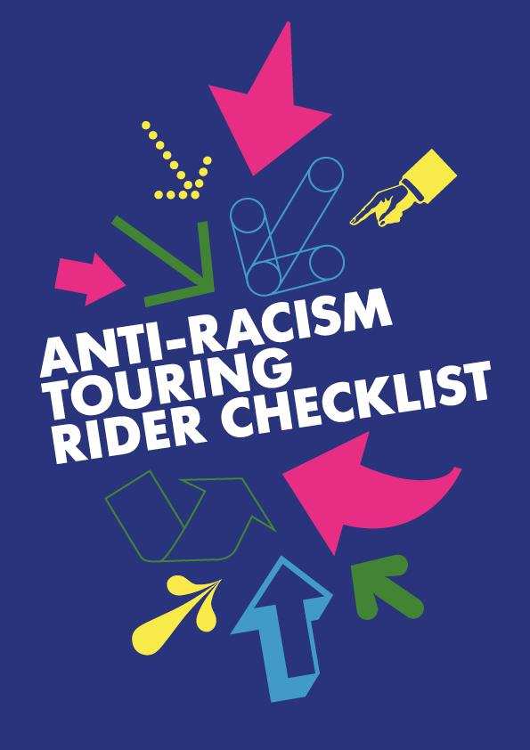

This checklist has been created to serve as a framework for discussion between Touring Companies and Venues, whereby it is mutually agreed which anti-racist actions are to be undertaken by the parties. Both baseline and good practice actions listed in the rider are given below, with some further space for additional actions. It is not presumed to be fit for purpose for every organisation in its immediate presentation, but rather to be adapted to best fit alongside current monitoring and data tracking.

In the Lead Up to Entering the Venue
Touring Company |  | Venue
Provide Opportunities for all employees (on permanent contract) to receive regular Anti-Racism training  Which provider:  When/How often: |  | Provide Opportunities for all employees (on permanent contract) to receive regular Anti-Racism training  Which provider:  When/How often:
Provide needs of the production and production members as early as as possible, inc.:  Access Requirements for Company Members  Technical and Design Requirements |  | Maintain a Safe Space Charter that is read at Meet and Greets/Get-ins and always available to in-house teams as part of the Venue’s Anti-Racism policy (or similar initiatives).  Located where on internal system?  Publicly available on website?
Provide a Company Info Pack minimum two weeks prior to arrival, which covers information about the company, the production and the Company Members, including headshots and name pronunciations  Timeline of production: |  | Respond positively and proactively to the technical requirements of the production and production requirements including specialisms on hair, make-up and lighting  Timeline of production:
Commit to increasing the ethnic diversity of staff to reflect the demographics from a wider range of communities if it currently does not.  Self-evaluation: |  | Commit to increasing the ethnic diversity of staff to reflect the demographics from a wider range of communities if it currently does not.  Self-evaluation:
Provide regular anti-racism training offers for the company’s pool of freelancers  Which provider:  When/How often: |  | Provide regular anti-racism training offers for the venue’s pool of freelancers  Which provider:  When/How often:
Ensure organisational awareness of cultural and religious calendars throughout the year  Notable events/dates during production engagement: |  | Ensure organisational awareness of cultural and religious calendars throughout the year  Notable events/dates during production engagement:
Carry out an induction process for rehearsals, including an out-loud reading of the rider

Timeline of production:
Welcome to the Venue
Touring Company |  | Venue
Provide Company Info Pack as close to contracting as possible and minimum two weeks prior to arrival, including:  - Headshots  - Pronunciations of names |  | Provide a welcome pack as close to contracting as possible and minimum two weeks prior to arrival, including:  - Demographics of the area  - Recommended places to eat and things to see and do  - Transport and map  - Licensed/approved taxi companies  - Full staff list.
Distribute the Venue’s Welcome Pack to the Company at least a week before arriving at the Venue.  Timeline of production: |  | Indicate to the Touring Company in advance who will be meeting them upon arrival at reception/leading a tour of the building.  Timeline of production:
Recce the venue prior to arrival (and preferably prior to programming) and meet with the staff team.  Timeline of production: |  | Make the Touring Company’s Company Info Pack available to staff throughout the building.  Timeline of production:
Provide clear communication and a dedicated contact person  Contact person: |  | Host a welcome for every production, regardless of length of run, which should be planned to allow for maximum attendance.
Provide clear arrival times for when the company will arrive together  Time (if known): |  | When:  Format:  Expected numbers:
 |  | Give every employee (including casual workers) the opportunity to attend the welcome events
Provide a fully accessible pre-recorded tour of the venue with captions

One-off recording, annual updates:
Wellbeing & Pastoral Care
Touring Company |  | Venue
Provide clear information to all freelancers from casting onwards concerning where a tour is going and what it will consist of  Comms methods:  Accessible Versions: |  | Designate a member of staff as a wellbeing support person who will share pastoral responsibility with the Touring company whilst they are at the venue. Staff members in this role will receive support and relevant training.  Contact person:
Provide a contact person within the company for support, and signposting to external professionals where needed; and make available the details of this support to all participating venues as part of any deal memo/contracting process.  Contact person: |  | Provide clear information regarding green rooms, toilets, staff only spaces etc  Comms methods:  Accessible Versions:
Provide technical and get-in schedules a minimum 2 weeks prior to the touring week, ensuring adequate time is allowed for company members to check into accommodation during daylight hours and scheduling this appropriately |  | Provide clear information on how the building operates (including opening, lock-up, on-site personnel etc)  Comms methods:  Accessible Versions:
Allocate dressing rooms with due consideration to cast size, cast makeup and any access needs.  Timeline of production: |  | Keep digs lists up to date and ensure all digs are pre-checked. Maintain regular contact with digs hosts to ensure all details are up to date and digs remain suitable for Touring Companies.  Annual check:
Pay touring allowance as early as possible so that digs can be booked well in advance. |  | Have a dedicated ‘Digs’ member of staff to liaise with the touring company and advise on areas and safety with particular regards to late evening finishes post-tech or show and company Members travelling home in unfamiliar cities.
Speak to each landlord before the visit, using the Safe Space Charter as a framework for discussion |  | Maintain a zero-tolerance approach in dealing with any reported incidents involving digs and digs list to be maintained and updated in accordance with this.
Advocate the anti-racism policy to Theatre Digs Booker so that it can become an accurate and up-to-date centralised digs system that Venues and Touring Companies will pass all information onto. |  | Advocate the anti-racism policy to Theatre Digs Booker so that it can become an accurate and up-to-date centralised digs system that Venues and Touring Companies will pass all information onto.
Sharing disclosure on training received  Which provider:  When/How often: |  | Sharing disclosure on training received  Which provider:  When/How often:
 |  | Ask digs hosts to sign up to a Safe Space Charter.
 |  | Diversify digs list and who is hosting.
Marketing
Touring Company |  | Venue
Provide details of audience targets, how these targets have been set and what expectation there is of meeting them  Timeline of production: |  | Provide details of audience targets, how these targets have been set and what expectation there is of meeting them  Timeline of production:
Provide actions for generating audiences and interest through dialogue and discussion  Timeline of production: |  | Provide actions for generating audiences and interest through dialogue and discussion  Timeline of production:
Share marketing strategy and audience development plans  Timeline of production: |  | Share marketing strategy and audience development plans  Timeline of production:
Discuss all language, image and assets used to market and sell the show, including where each party has distinct specialisms and knowledge which can support the approach to marketing and sales  Timeline of production: |  | Discuss all language, image and assets used to market and sell the show, including where each party has distinct specialisms and knowledge which can support the approach to marketing and sales  Timeline of production:
Meet with Box Office and Marketing staff prior to arrival (as part of recce) or before the first performance to discuss production/themes/company  Timeline of production: |  | Share marketing plans and print/pull ups with the Touring Company as soon as possible after programming, and well in advance of the tour, so there is clarity of expectation from the beginning.  Timeline of production:
 |  | Share internally (with marketing teams) reasons for programming and positive messaging around programming
Consider the placing of print, pull-ups and other prominent marketing materials and involving Touring Companies within that decision making.

Basis for decisions:
Internal team responsible:
Brochures and Websites
Touring Company |  | Venue
Consider the implications of stereotypes when choosing images and text, and to seek broader, diverse feedback to support the process where required  Internal decision maker:  Consulted: |  | Consider the implications of stereotypes when choosing images and text, and to seek broader, diverse feedback to support the process where required  Internal decision maker:  Consulted:
Provide boiler plate descriptors for local PRs and coverage. This should be created in conjunction with the venue and reflect the Venue’s knowledge of their area.  Timeline of Production: |  | Provide clear word counts and requirements of copy, and to consult with Touring Companies before editing or changing it, both on longer versions/on webpages as well as short copy in brochures.  Timeline of Production:
Audiences
Touring Company |  | Venue
Establish mechanisms for inclusivity to improve the audience experience. This should include working together to break down unhelpful expectations around audience behaviour and etiquette and agree where the perceived etiquette can and should be challenged  Mechanism established:  Usability check:  Responsibility lies with: |  | Establish mechanisms for inclusivity to improve the audience experience. This should include working together to break down unhelpful expectations around audience behaviour and etiquette and agree where the perceived etiquette can and should be challenged  Mechanism established:  Usability check:  Responsibility lies with:
Discuss presumptions around who audiences are and where ‘value’ is placed, in order to welcome all audiences irrespective of background, socio-economics or race  Mechanism established:  Usability check:  Responsibility lies with: |  | Discuss presumptions around who audiences are and where ‘value’ is placed, in order to welcome all audiences irrespective of background, socio-economics or race  Mechanism established:  Usability check:  Responsibility lies with:
Undertake an evaluation at the end of the production to implement learnings and sharing outcomes.  Evaluation lead:  Sharing practice: |  | Undertake an evaluation at the end of the production to implement learnings and sharing outcomes.  Evaluation lead:  Sharing practice:
Discuss with the Venue Front of House and marketing teams work around creating/supporting an inclusive and equitable space for audiences.  Responsibility lead: |  | Interrogate the offer within the building (food, space to work/socialise) as a whole, and encourage accessibility for everyone  Timeline:  Annual review:  Responsibility lead:
Interrogate the language used across the company website, assets and marketing materials to evaluate how welcoming and inclusive it is to audiences  Timeline:  Annual review:  Responsibility lead: |  | Interrogate the language used within the building (signage, instructions, announcements etc.) and evaluate how welcoming and inclusive it is to audiences  Timeline:  Annual review:  Responsibility lead:
Have a dedicated staff member responsible for audience development in post as soon as possible, in order to make wraparound events happen in the timeline needed for the venues  Responsibility lead: |  | Confirm and share a clear and comprehensive budget for audience development that can be allocated to certain shows that will help achieve its aims.  Responsibility lead:
Discuss with the Touring Company their current audience make-up and what the expectations surrounding the Production are.

Timeline of Production:
Review process:
Responsibility lead:
Data Sharing
Touring Company |  | Venue
Share full data reports (within GDPR regulations) of the entire tour  Timeline of Production:  Review process:  Responsibility lead: |  | Share all data (within GDPR regulations) from the visiting show with the touring company responsible  Timeline of Production:  Review process:  Responsibility lead:

As agreed on date:

Between:

The checklist is to be reviewed regularly and evaluated at the end of the production.


